**Crontab automation**

**Useful links / resources:**

<https://crontab.guru/> - Crontabs and examples

<https://help.ubuntu.com/community/BackupYourSystem/TAR> - Tar guide

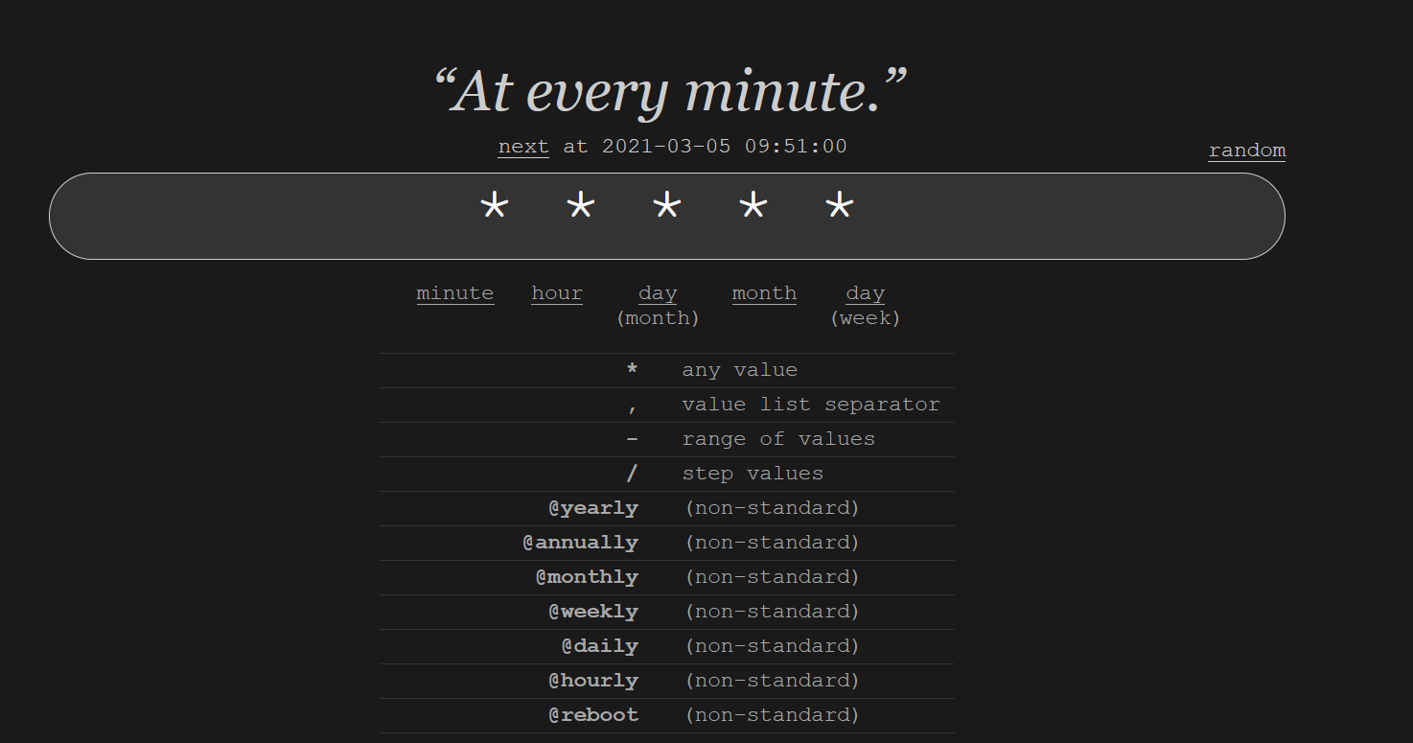

* **Crontabs editing:**
  + Use *crontab -e* to edit a user’s individual crontab.
  + Use *sudo crontab -e* to edit the tab under root level permission.
  + *crontab -l* will show the crontab for your current user account.
  + *Sudo crontab -u [user] -l* will allow you to view cron tabs of other users.
  + */* is used to use ‘step’ values. (Example *\*/30 * * * \** will run the job every half-hour. See the cron-guru link above, scroll down, and click examples to see more)
  + To reset the default editor, type *rm ~/.selected_editor* and you will be prompted to select an editor once again.

**Critical File Locations**

*/var/www/html/* - Contains all the wordpress configuration files

*/etc/mysql/* - contains all the MySQL configuration files

*/etc/apache2/* - contains all apache2 configuration files

*/var/spool/cron/crontabs/*

*/etc/passwd/* - contains information about users on the system

**Backups**

* **tar**
  + Use tar to compress and backup files for a directory.
  + For example, this command: *tar -cvpzf ~/Backups/BackedupWordpress /var/www/html*
  + The above command will take all the contents in the /var/www/html directory (where all the wordpress configuration files are) and shove them into a tar.gz folder in the ~/Backups/ directory.
  + *sudo tar -xvpzf ~/Backups/BackedupWordpress --numeric-owner (MOVE TO THE ROOT DIRECTORY WHEN YOU DO THIS)*
  + Above command will backup the contents of the backup to the original directory and keep numeric owners of the file.
* **Backing up MySQL with mysqldump**
  + To backup a MySQL database, use the *mysqldump* command.
  + *sudo mysqldump -u root -p wordpress > ~/Backups/wordpressBackup.sql* (This command will take the entire database specified [wordpress] and make a copy of it.)
  + To restore a database: Go into *mysql -u root -p* (Enter the password)
  + *create database wordpress;* (This creates an empty database called wordpress)
  + Leave MySQL, then, type the following command: *sudo mysql -u root -p -h localhost wordpress < wordpressBackup.sql*
  + That command will populate the wordpress database that was freshly created with the backed up data from the wordpress sql db backup.
* **Backing up Apache2**
  + Do the same things done for the wordpress files done in the **tar** example above.
  + Only real difference is that the configuration files are in */etc/apache2/*

**Useful Bash Scripts**

**(backupApache.sh) Apache2 Backup:**

*#!/bin/sh*

*sudo tar -cvpzf ~/Backups/apache2_backup_$(date +%Y-%m-%d %H:%M:%S) /etc/apache2*

**(backupMySQL.sh) MySQL Database Backup:**

*#!/bin/sh*

*sudo mysqldump -u root -p[password] wordpress > ~/Backups/wordpressBackup_DB_$(date +%Y-%m-%d %H:%M:%S).sql*

**(wordpressBackup.sh) Wordpress Configs Backup:**

*#!/bin/sh*

*sudo tar -cvpzf ~/Backups/BackedupWordpress_$(date +%Y-%m-%d %H:%M:%S)*

*/var/www/html*

**(allBackups.sh) All three main service backups**